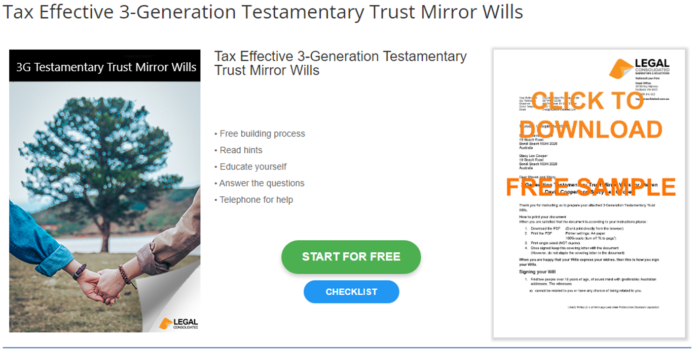

Tax Effective 3-Generation Testamentary Trust Mirror Wills - Checklist

Start building your document for free:
- Select START FOR FREE - the building process is free: https://legalconsolidated.com.au/mutual-wills-tax-effective-with-choice-of-beneficiaries-intro/
- Answer the questions. Read the hints and watch the training videos. Educate and be empowered.
- Telephone the law firm for help answering the questions.
- Select Lock and Build and enter your credit card details.
- Within seconds, you get our cover letter and the Mirror Wills.
Will maker and
Spouse details

• Your Full Name & Address

• Your Spouses Full Name & Address

• Full Alias Name: if any assets in another name?

Age of Majority  •After you both die, the age your Beneficiaries get their interest in your Estate? | The default is 18 years of age. Otherwise select another age:
Backup Executors  • After you are both dead, FULL NAME of your Executors | Normally, all your children or Beneficiaries. (The best Executors are the persons getting your estate.)
Guardians if any your children are currently under 18 | E.g. the 4 grandparents. FULL NAMES & ADDRESSES
Specific Gifts  • Describe Gift and FULL NAME & ADDRESS of the person | Best to leave this blank.
Residuary Beneficiaries  • FULL NAME, Address  Age of Majority (if required)  Percentage interest - %  This must equal 100% | E.g. First Middle Surname, 23 Sample Street, Suburb, NSW: 33 13/%
Disaster Clause have young children? You travel in the same car, and you all die together | E.g. 50% to your side of the family. 50% to spouse’s side of the family.
Full Name of person that may challenge your Will  Full Name of person that may challenge your spouse’s Will | E.g. ex-spouses, children being cut out of the Will
Contemplation of Marriage | If you and your spouse are in a defacto relationship then put in each other’s FULL NAMES.
Contemplation of Divorce
Name of person you may divorce. Obviously, this is NOT your current spouse.
