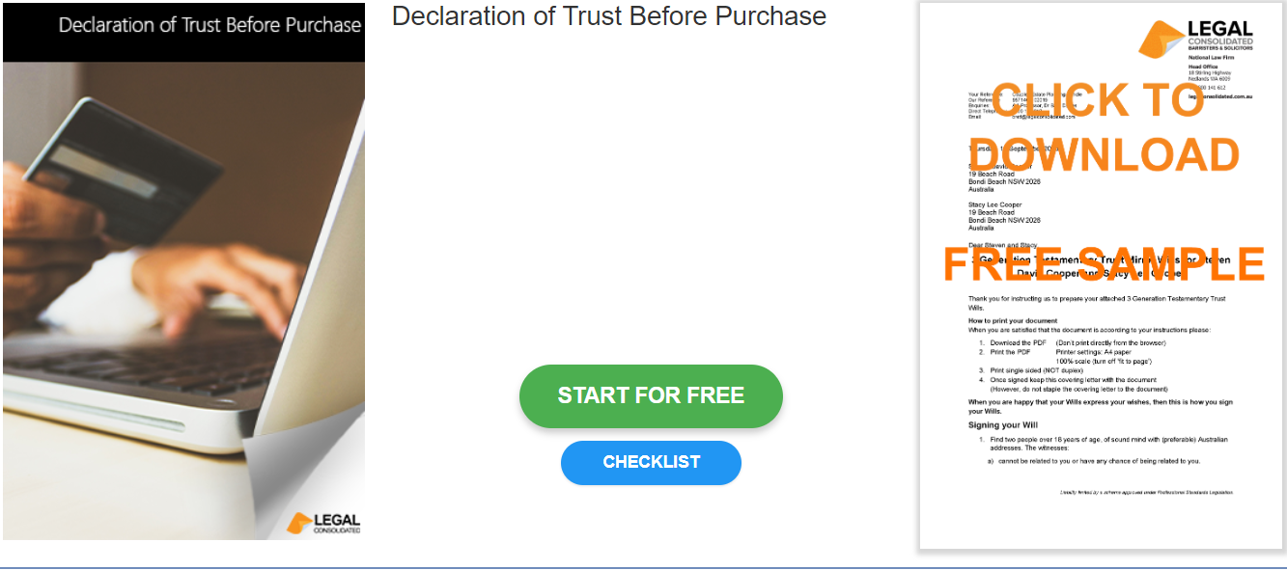
\

Declaration of Trust Before Purchase

Start building your document for free:
- Select START FOR FREE - the building process is free: https://legalconsolidated.com.au/declaration-of-trust-before-purchase/
- Answer the questions. Read the hints and watch the training videos. Educate and be empowered.
- Telephone the law firm for help answering the questions.
- Select Lock and Build and enter your credit card details.
- Within seconds, you get our cover letter and the finished document.
Beneficiaries

• Beneficiary Name
(ACN if a company)

• Beneficiary Address
Vendor

• Vendor Name
(ACN if a company
)
• Vendor Address
Property

• Trust Property

• Acquired date

