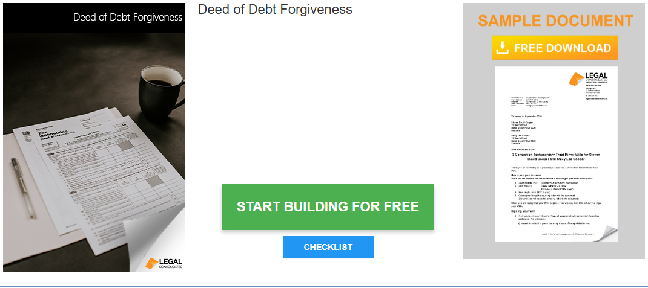

Deed of Debt Forgiveness

Start building your document for free:
- Select START BUILDING FOR FREE - the building process is free: https://legalconsolidated.com.au/company-power-of-attorney/
- Answer the questions. Read the hints and watch the training videos. Educate and be empowered.
- Telephone the law firm for help answering the questions.
- Select Lock and Build and enter your credit card details.
- Within seconds, you get our cover letter and the finished document.
Person that is owed the money

• Person Name
(ACN if a company)

• Person Address

• If Trustee of a Trust
Trust Name

Person that owes the money

• Person Name
(ACN if a company)

• Person Address

• If Trustee of a Trust
Trust Name

